**Soldering station**

|  |  |
| --- | --- |
| Author | Jelle Claes |

Content

1 Introduction 1

2 Material and methods 2

3 Results 3

3.1 Main PCB 3

3.1.1 Power supply 3

3.1.2 PWM 4

3.1.3 Thermocouple 4

3.1.4 CPU 5

3.2 Display 6

3.3 PCB design 7

3.4 Case 8

4 Discussion 9

# Introduction

The built device is a soldering station. The project comes from the Elektor magazine from May/June 2021. The purpose of the device is to heat up a soldering iron to a temperature entered by the user with a rotary encoder with a push button. The temperature shows on a seven segment four digit display. This device is a fairly simple project. The device itself is an useful item. Almost every person in the field needs one for his/her own projects. The project uses the design process of a PCB (Printed Circuit Bord) and gives a view of the difficulties during every step in the process. The Application Note discusses several different points, for instance: the used materials and methods, the testing results, a discussion of the obtained results and improvement areas.

# Material and methods

The used materials consist of a few different component types like: resistors, inductors, capacitators, semiconductors, … . Table 1 is the BOM(Bill Of Materials) and lists the used components. The PCB consists of two different PCB’s that are connected to each other by a flat cable. The materials of both PCB’s are listed in one BOM.

Table 1: BOM

|  |  |  |  |
| --- | --- | --- | --- |
| **Component** | **Component number** | **Amount** | **Supplier** |
| SOLDERINGIRON |  |  |  |
| Bridge_Rectifier | B1, B2 | 2 | LCSC |
| 10µf | C1, C8, C13 | 3 | LCSC |
| 100µf | C2 | 1 | LCSC |
| 4700µf | C3 | 1 | LCSC |
| 10n | C4, C5, C6, C7 | 4 | LCSC |
| 100n | C9, C10, C11, C12, C14 | 5 | LCSC |
| Zener_Diode | D1 | 1 | LCSC |
| 1N4007 | D2 | 1 | LCSC |
| 1N4148 | D3 | 1 | LCSC |
| OKI-78SR-5/1.5-W36-C | IC1 | 1 | MOUSER |
| Dual_Opamp | IC2 | 1 | MOUSER |
| ATMEGA4809 | IC3 | 1 | MOUSER |
| 2060-452/998-404 | K1, K2, K3, K4 | 4 | CONRAD |
| 22-28-4033 | K5, K6, K11 | 3 | / |
| M22-2510205 | K7 | 1 | / |
| 61300411121 | K8 | 1 | / |
| TSW-103-07-G-D | K9 | 1 | / |
| 5x2 box pinheader | K10 | 1 | CONRAD |
| 61300511121 | K12 | 1 | / |
| Common_Mode_Choke | L1 | 1 | MOUSER |
| Choke | L2 | 1 | LCSC |
| 68K | R1 | 1 | LCSC |
| 10K | R2, R18, R19 | 3 | LCSC |
| 4K7 | R3, R5, R17, R20, R21, R22 | 6 | LCSC |
| 100 ohm | R4, R9, R13 | 3 | LCSC |
| 5K6 | R6, R8, R12, R14 | 4 | LCSC |
| 18K | R7, R10, R11 | 3 | LCSC |
| 1M | R15 | 1 | LCSC |
| 10M | R16 | 1 | LCSC |
| RELAY_GENERAL_PURPOSE | RE1 | 1 | MOUSER |
| Transistor_NPN | T1, T2, T5 | 3 | LCSC |
| Transistor_PNP | T3 | 1 | LCSC |
| MOSFET_P | T4 | 1 | LCSC |
|  |  |  |  |
| DISPLAY |  |  |  |
| 10nf | C1, C2, C3 | 3 | LCSC |
| 100nf | C4 | 1 | LCSC |
| 100µf | C5 | 1 | LCSC |
| PEC11R-4220F-S0012 | ENC1 | 1 | MOUSER |
| TM1637 | IC1 | 1 | LCSC |
| 5x2 box pinheader | K1 | 1 | CONRAD |
| CA56-12SYKWA | LD1 | 1 | GOTRON |
| 10K | R1, R2, R3 | 3 | LCSC |

The total components price is 91,26 euros. The price is reduced by making a combined order with a group of twenty students. This resulted in a lower shipping price.

The software is published by Elektor. They provided the code for the whole soldering iron. The soldering iron converts the input voltage to a lower voltage. The user selects the wanted temperature and starts heating the soldering iron to the selected temperature. The microcontroller uses an OPAMP to measure the temperature of the soldering iron.

# Results

The project consists of two different PCB’s.

## Main PCB

The main PCB has 4 different parts that are connected to each other. The four parts are a power supply, PWM, [thermocouple](https://context.reverso.net/vertaling/engels-nederlands/thermocouple) and the CPU. Each part has a different purpose.

### Power supply

The first part is the power supply. Picture 1 shows the power supply’ schema.

Picture 1: Power supply schema

The main purpose of the power supply is rectifying the incoming voltage and rounding it down.

### PWM

The second part is the PWM. The PWM’s schema is shown in picture 2.

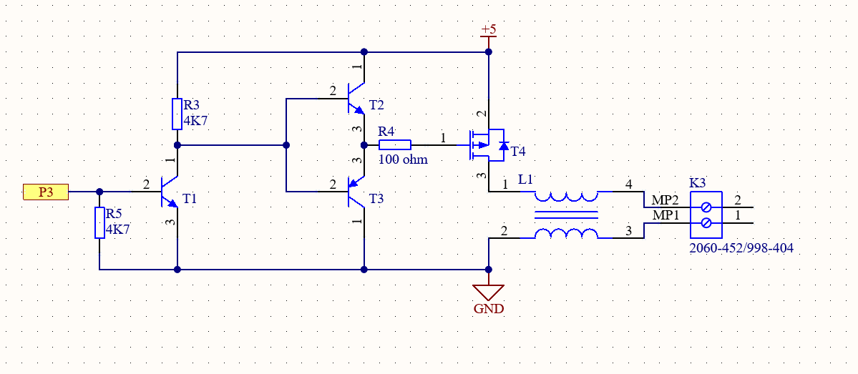

Picture 2: PWM schema

This part is the power of the soldering iron.

### [Thermocouple](https://context.reverso.net/vertaling/engels-nederlands/thermocouple)

The third part is the thermocouple. Picture 3 shows the schema of this part.

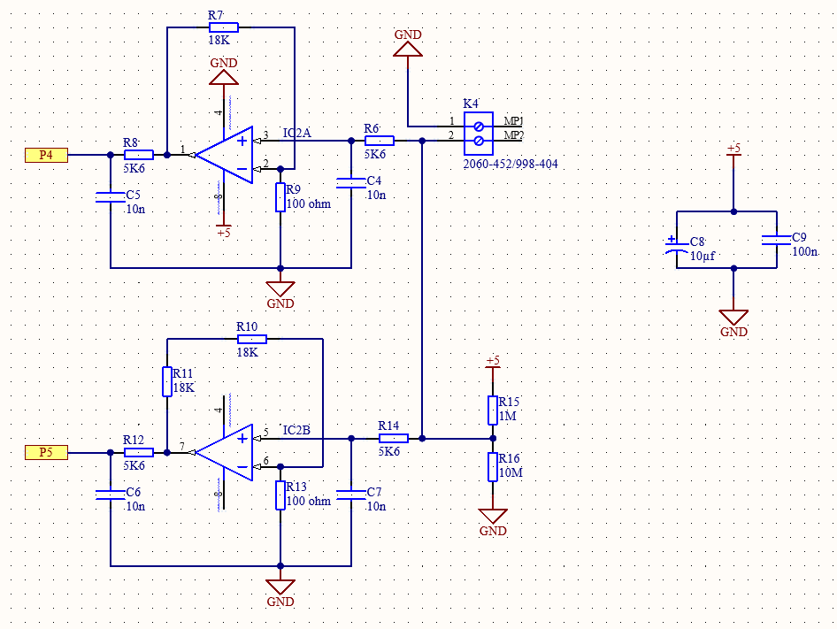

Picture 3: Thermocouple schema

This part upscales the temperature of the soldering iron to measure it’s temperature correctly.

### CPU

The fourth part of the main PCB is the most important one; the CPU. The CPU is the brain of the whole PCB. Picture 4 shows the CPU’s schema.

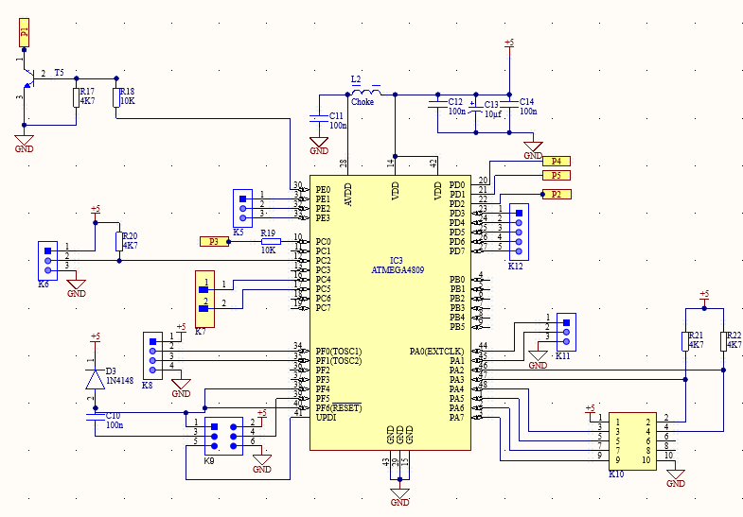

Picture 4: CPU schema

## Display

The second PCB is the display. It displays the temperature and allows the user to choose a temperature. Picture 5 visualizes the schema.

Picture 5: Display schema

This PCB is connected to the main PCB with a flat cable in K1. Another option is to make it part of the main PCB. There are some pros and cons for combining it in one PCB. The pros are: the price is dropped down because you don’t need a second stencil, the design is easier to understand and to troubleshoot. The biggest con is one big PCB is verry difficult to mount in the case. This negative point is the reason why two separate PCBs are used.

## PCB design

The PCB design is the most important step of the whole process. A lot of problems can arise. The issues that can surface are wrong connections and wrong footprints. Picture 6 visualises the main PCB’s design. Picture 7 shows the display design.

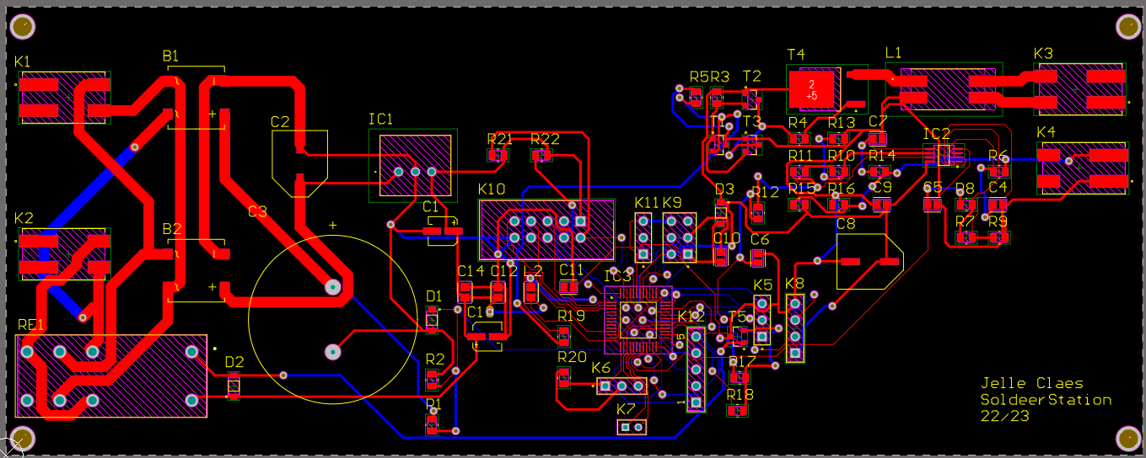

Picture 6: Main PCB design

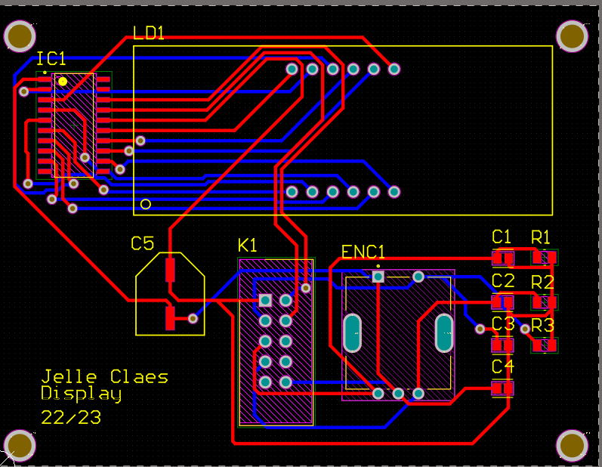

Picture 7: Display PCB design

## Case

The case is an important part of the project. The case is the part the user interact with; a user is looking at

it, touching it,…. It is important that every item fits and doesn’t move. The case for this project is a crate of

beer from Cristal Alken. Picture 8 shows the 3D design of the case.

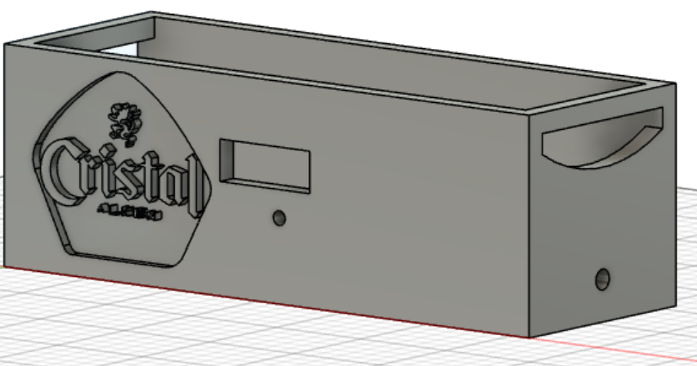

Picture 8: 3D design of the case

Picture 9 shows the top.

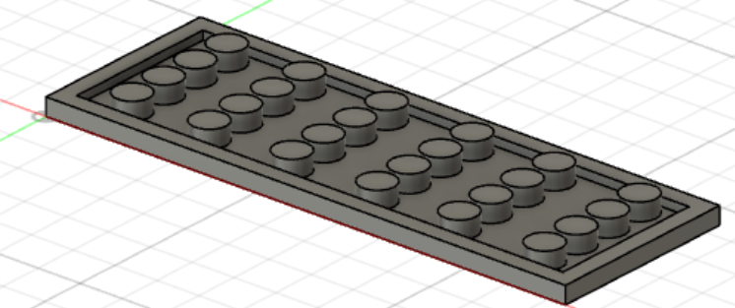

Picture 9: Top of the case

# Discussion

The design process starts with making the libraries. A problem while making the library was that the footprint of the MOSFET was wrong. This was solved during the soldering of the PCB by connecting wires to the correct pad. The second step of the design process is making the schematic design. One little mistake made in the PWM was that the +5 volt should be Vin. This is fixed by scratching the 5 volt line and connecting it to the Vin with a wire. The third and final step is the PCB design. Several issues were encountered like choosing the wrong footprint, making the holes too small for the leads,…. These faults correlate more or less with the faults in the library. When soldering the PCB some small mistakes were made like bad contact. These faults were corrected easily. The other problems were also corrected during this stage. The final stage was the case. The biggest problem is that the case is too big to print. Instead of 3D printing the case is laser cut from wood.

This project was a great learning experience. The biggest improvement point is to think about using both sides of the PCB more efficiently. Another improvement is to think upfront on the size of the case to ensure that a smaller one can fit all the parts. Picture 10 and 11 contain the final version of the PCB. Picture 10 shows as well how the faults were corrected. The yellow wires connect the Vin and fix the footprint.

Picture 10: picture of the finished main PCB

Picture 11: picture of the final display